

**TITLE: -** Hotel Review Sentiment Analyzer

**NAME: -** PUJITHA KODURU

**Roll NO: -** 23BCE20090

**College Name: -** Vellore Institute of Technology (VIT), Amaravati

**Branch: -** Computer science and Engineering

**Date of Submission: -** 30-06-2025

**Table of Content**

|  |  |  |
| --- | --- | --- |
| S.NO | Topic | Page.NO. |
| 1. | Introduction | 3 |
| 2. | Objectives | 3 |
| 3. | Tools | 3-4 |
| 4. | Methodology | 4 |
| 5. | Code snippets | 5-9 |
| 6. | GitHub Link | 10 |
| 7. | Conclusion | 10 |

**1. INTRODUCTION**

The hospitality industry relies heavily on customer satisfaction, and hotel reviews offer valuable insights into guest experiences. Manually analysing thousands of reviews is time-consuming and impractical. The **Hotel Review Sentiment Analyzer** addresses this challenge using AI-powered natural language understanding to automatically classify customer reviews by sentiment and identify specific service-related topics such as room service, food quality, and staff behaviour.

**2. OBJECTIVES**

To build an AI model that analyzes hotel reviews and detects sentiment.

To extract and tag service-related insights from reviews.

To help hospitality managers identify areas of improvement and strengths.

To generate structured reports that summarize guest feedback.

**3. TOOLS**

|  |  |
| --- | --- |
| Category | Tools/Technologies |
| Programming Language | Python |
| Libraries | pandas, IBM-Watson-machine-learning |
| AI Model | IBM watsonx.ai Foundation Models (FLAN-T5) |
| Platform | |  | | --- | |  |  |  | | --- | | IBM Watsons Prompt Lab | |
| Cloud Storage | IBM Cloud Object Storage (COS) |
| IDEs | Google Colab |

**4. Methodology:**

1. **Data Collection**:  
Hotel customer reviews are collected in .xlsx format with a single column named review.

2. **Few-shot Prompting Setup**:  
Example reviews are crafted to show the AI how to classify sentiment and extract topics.

3. **Model Initialization**:  
The google/flan-t5-xxl foundation model is used in IBM Watson Prompt Lab or through the Python API.

4. **Review Analysis**:  
Each review is passed to the model via prompts. The AI returns both sentiment (Positive, Negative, Neutral) and service topics (e.g., food quality, staff behavior).

5. **Post-processing**:  
The output is split into Sentiment and Topics. Final results are exported to Excel.

**5. Code Snippets**

1. **Importing and Initializing**

This section imports necessary libraries:

* pandas for data handling,
* API Client to connect with IBM Watson Machine Learning,
* and Model to access foundation models for text analysis.

INPUT:

OUTPUT:

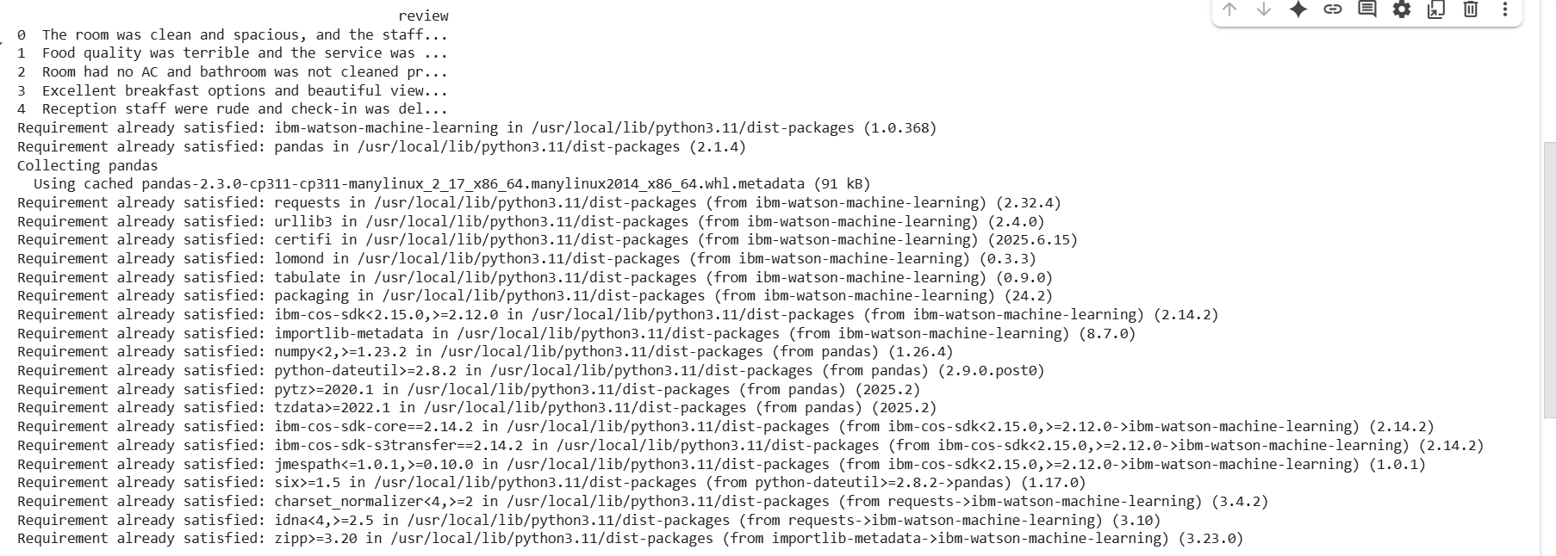

1. **Set IBM Credentials and Connect**

This code sets up your IBM Cloud credentials and project ID to securely connect your Python environment to Watson Machine Learning services.



1. **Load and Display Dataset**

This code reads the Excel file (*hotel_reviews.xlsx*) containing hotel reviews, removes empty entries, and prints a sample of the dataset.

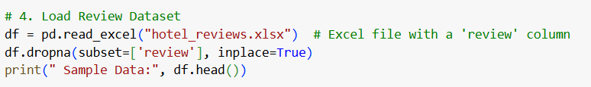

OUTPUT:

1. **Create Prompt Template (Few-shot Examples)**

This prompt guides the foundation model by showing sample input-output examples (few-shot prompting). It teaches the model how to classify reviews and extract relevant service topics.

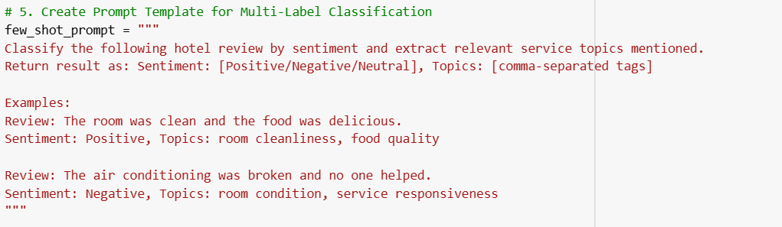

1. **Initialize the Foundation Model**

Here, the *FLAN-T5-XXL* foundation model is initialized with your credentials. This model is responsible for generating sentiment and topic classification outputs.

**f. Define Review Analysis Function**

This function sends a hotel review to the foundation model, combines it with the few-shot prompt, and returns the sentiment and topic tags. It also handles API errors gracefully.

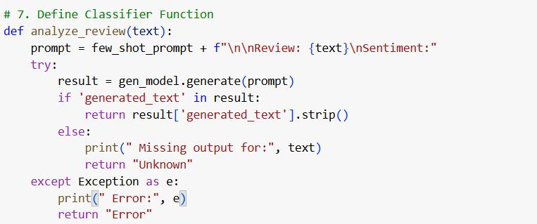

**g.Apply Model to All Reviews**

This line applies the analyze_review() function to every entry in the dataset, storing the model's output (sentiment and topics) in a new column called Analysis***.***

h. **Split Output into Sentiment and Topics**

This block separates the model's response into two columns: Sentiment and Topics, making the output easier to analyze and visualize.

Output:

1. **Save Results to Excel**

This line exports the final analyzed dataset, including sentiment and topics, into a new Excel file named *hotel_review_analysis_output.xlsx*.

Output:



**6. GitHub link**

**7. Conclusion**

The Hotel Review Sentiment Analyzer successfully automates the classification of customer reviews into sentiment categories and identifies specific service aspects mentioned. It reduces manual review efforts, highlights key strengths and problem areas, and provides clear, structured insights for hotel management. The use of IBM watsonx foundation models ensures accurate language understanding, making it a powerful tool for modern hospitality analytics.